**Laboratory Report Cover Sheet**

| SRM INSTITUTE OF SCIENCE AND TECHNOLOGY  Faculty of Engineering and Technology  Department of Electronics and Communication Engineering |
| --- |
| **18ECC102J Electronic Devices**  **III Semester, 2021-2022 (ODD Semester)** |

**Title of Mini Project: Bike Turning Signal Circuit**

**Date of Submission: 10/02/2022**

| **Particulars** | **Max. Marks** | **Marks Obtained** | | |
| --- | --- | --- | --- | --- |
|  |  | **Name:**  **Tamurai Selvan** | **Name:**  **Yakub Mathew** | **Name:**  **Kunal Keshan** |
|  |  | **Register No.**  **RA2011004010036** | **Register No.**  **RA2011004010044** | **Register No.**  **RA2011004010051** |
| Design | 20 |  |  |  |
| Demo verification &viva | 15 |  |  |  |
| Project Report | 05 |  |  |  |
| **Total** | **40** |  |  |  |

**REPORT VERIFICATION**

**Staff Name: Dr. K.V. Phanikumar**

**Signature:**

**Objective:**

To build a Bike Turning Signal Circuit using the mentioned electronic components in a software, test it and build the circuit.

**Hardware Requirements:**

* Resistor 180Ω
* Resistor 100KΩ
* Resistor 470KΩ
* Capacitor 1µF
* 555 Timer IC
* LEDs – 2
* Diodes (1N4007) – 2
* SPDT Slide Switch
* 9V Battery
* Connecting Wires
* Breadboard

**Software Requirements:**

* [Upverter PCB Designer](https://upverter.com/)

**Introduction:**

Turn Indicator Lights also known as Directional Indicators or Blinkers, Flashers, are an essential part all automobiles whether a bike or a car. They inform other road users of our intent to turn left or right.

Bike Turning Signals are used to indicate the intent of left turn or right turn to other users of the road.

**Principle:**

The objective of this circuit is to indicate the left or right turn for the bike/vehicle. The main component of this circuit is the infamous 555 Timer IC. Here, this 555 timer acts as an Astable multivibrator.

It generates the pulse signal with variable width. Using this variable width of the pulse, we can set different time delays for the LEDs (ON and OFF for LEDs).

The circuit consists of two important resistors (100KΩ and 470KΩ), which are connected to a 555 timer and these are used to set the time delay for LEDs. The output of the 555 Timer IC is given to either the LEFT indicator LED or the RIGHT Indicator LED using a Slide Switch.

1n4148 signal diode is connected in reverse bias at the output to maintain constant current at the output. BC547 (NPN) Transistor switches the LED’s ON and OFF based on the base currents.

330-ohm resistors are used to drop the voltage otherwise LEDs may get damaged. Here we can vary the time width of output pulse by varying the resistance or capacitance value.

**Design:**

In this circuit, the 555 timer produces a pulse signal with variable width. The pulse width is varied by varying resistance or capacitance value (100KΩ, 470KΩ or 1µF). Pins 2 and 6 are shorted to allow triggering after every timing cycle.

The fourth pin is reset, it is shorted with VCC (8th pin) to avoid sudden resets. The 7th pin is discharging pin, it is connected to the 6th pin through a 470KΩ resistor.

For a 555 Timer, capacitor C charges through resistors RA and RB. Now because of internal op-amps, capacitor C discharges through resistor RB. 555 timer internally consist of 2 operational amplifiers, one D flip flop and one NPN transistor.

The obtained pulse from the 555 timer is applied to the LEDs through the slide switch to make the LEDs ON and OFF with some delay. Here the operating voltage of LEDs is around 2 to 3v but from the battery, we get a 9V supply. So, we need to drop the remaining voltage. To drop this voltage, we are using resistors in series with LEDs.

**Circuit:**

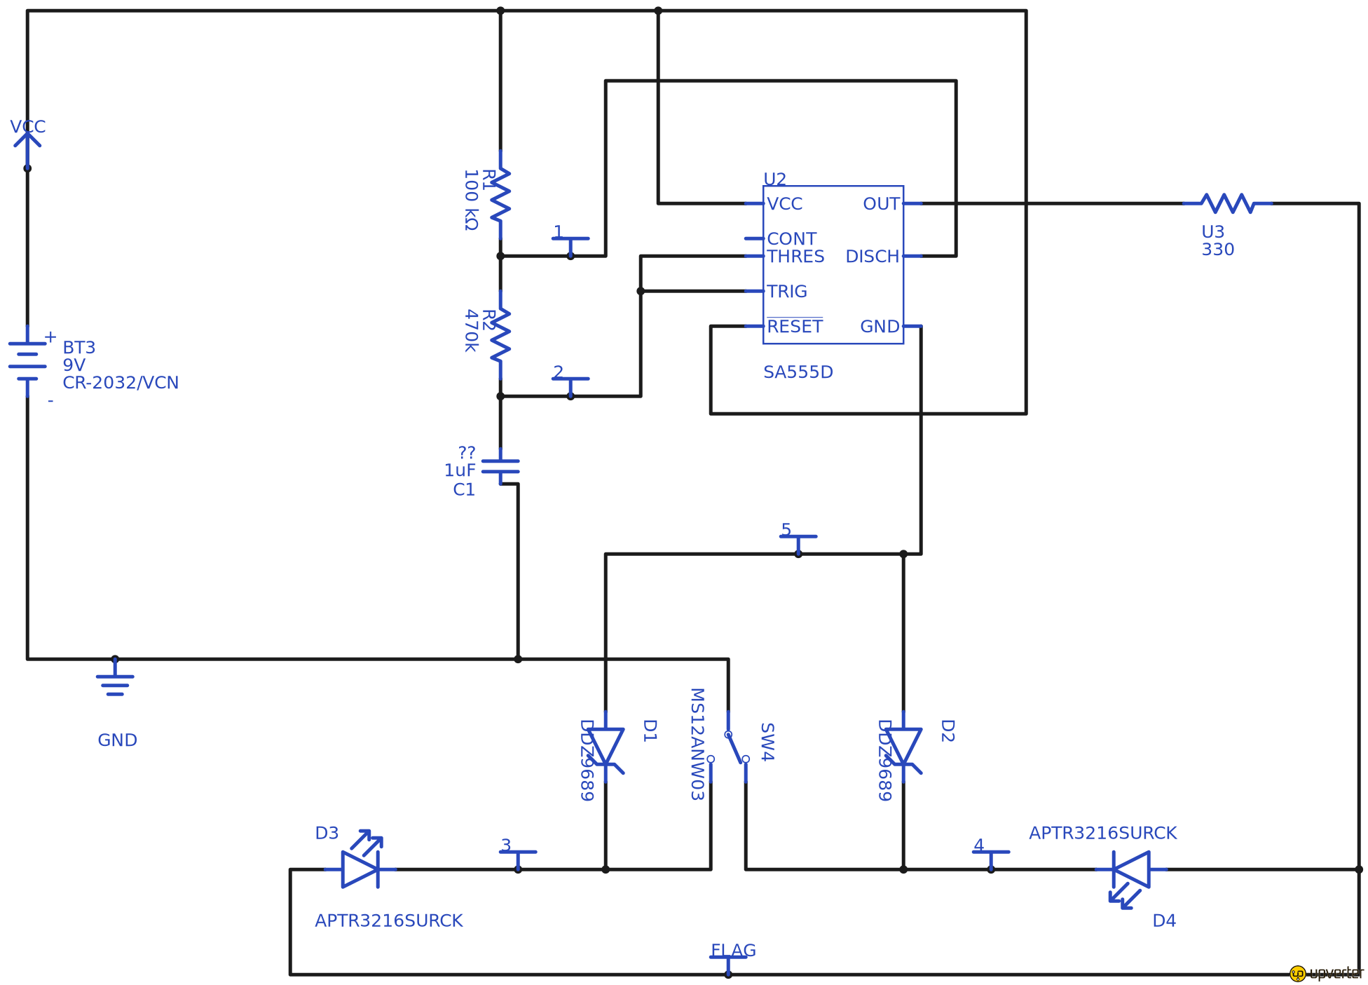

**Result:**

The Bike Turning Signal Circuit was built and tested using the Software available with the required components.

**Conclusion:**

With this Mini Project we learnt how to create a Bike Turning Signal Circuit with various electronic components.